SQL OPERATIONS PRACTICAL
Table Used: CUSTOMERS
CREATE TABLE CUSTOMERS (
ID INT PRIMARY KEY,
NAME VARCHAR(20),
AGE INT,
ADDRESS VARCHAR(50),
SALARY DECIMAL(10,2)
);
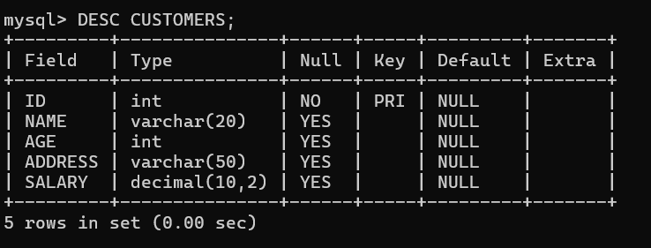
INSERT INTO CUSTOMERS (ID, NAME, AGE, ADDRESS, SALARY) VALUES
(1, 'Prajwal', 21, 'Chandanapuri', 1000000),
(2, 'Prafull', 22, 'Chalisgaon', 90000),
(3, 'Sarthak', 20, 'Niphad', 400000),
(4, 'Shreyas', 21, 'Sangamner', 500000),
(5, 'Avej', 23, 'Loni', 600000);
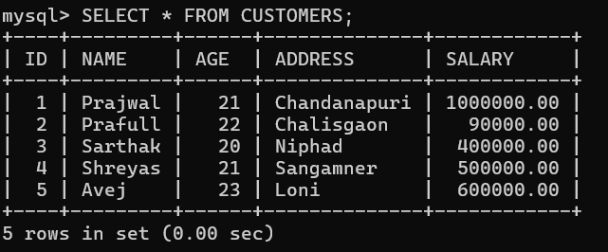

a) ALTER TABLE
Used to modify structure of existing table.
-- Add new column
ALTER TABLE CUSTOMERS ADD PHONE VARCHAR(15);
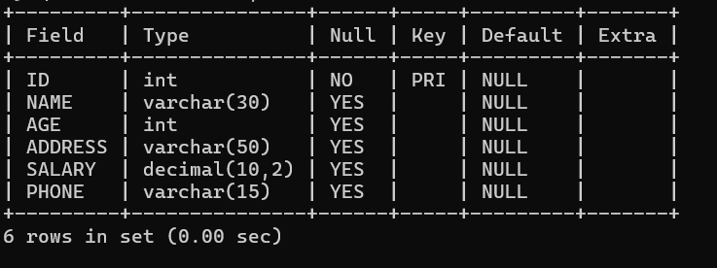
-- Modify column
ALTER TABLE CUSTOMERS MODIFY NAME VARCHAR(30);
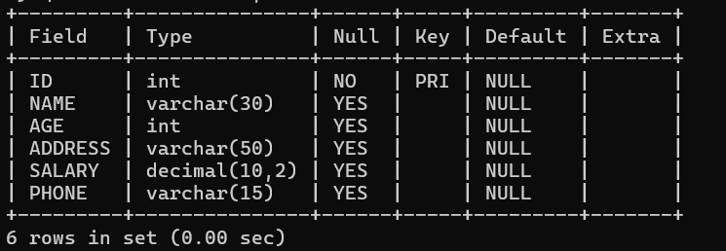
-- Drop column
ALTER TABLE CUSTOMERS DROP COLUMN PHONE;
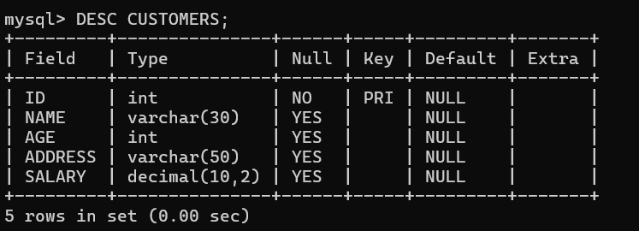

b) DROP TABLE
DROP TABLE CUSTOMERS;
Deletes entire table permanently.
c) INDEX OPERATIONS
Used to improve query performance.
-- Create index
CREATE INDEX idx_name ON CUSTOMERS(NAME);
SHOW INDEX FROM CUSTOMERS;
-- Drop index
DROP INDEX idx_name ON CUSTOMERS;
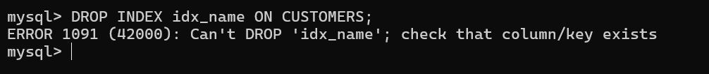
d) RELATIONAL OPERATORS (AND, OR)
-- AND Operator
SELECT ID, NAME, SALARY
FROM CUSTOMERS
WHERE SALARY > 2000 AND AGE < 25;
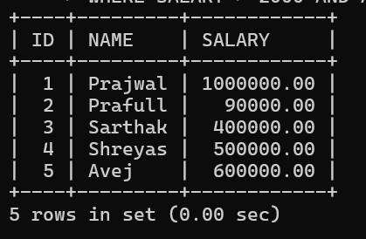
-- OR Operator
SELECT ID, NAME, SALARY
FROM CUSTOMERS
WHERE SALARY > 2000 OR AGE < 25;
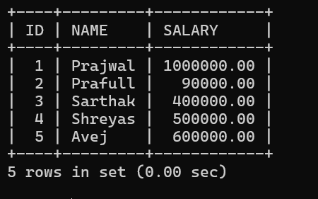
e) PATTERN MATCHING (LIKE)
-- Salary starting with 200
SELECT * FROM CUSTOMERS
WHERE SALARY LIKE '400%';
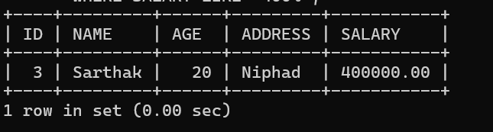
-- Name starts with 'K'
SELECT * FROM CUSTOMERS
WHERE NAME LIKE 'S%';
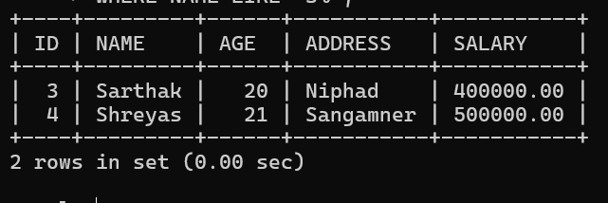
-- Name contains 'a'
SELECT * FROM CUSTOMERS
WHERE NAME LIKE '%a%';
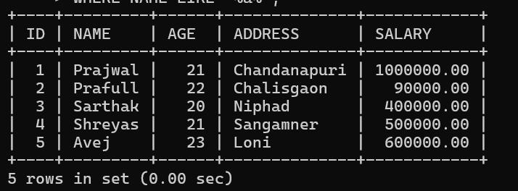

f) AGGREGATE FUNCTIONS WITH GROUP BY & HAVING
-- Total salary by age
SELECT AGE, SUM(SALARY) AS TOTAL
FROM CUSTOMERS
GROUP BY AGE;
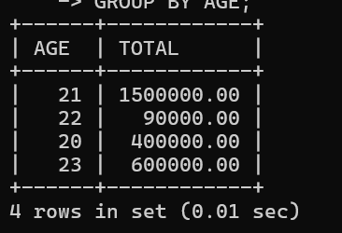
-- Using HAVING
SELECT AGE, SUM(SALARY)
FROM CUSTOMERS
GROUP BY AGE
HAVING SUM(SALARY) > 500000;
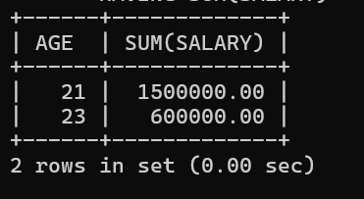
g) NESTED QUERIES
SELECT *
FROM CUSTOMERS
WHERE ID IN (
SELECT ID FROM CUSTOMERS WHERE SALARY > 450000
);
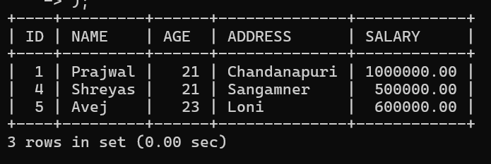
h) SET OPERATORS
CREATE TABLE TABLE1 (
NAME VARCHAR(20)
);
SELECT * FROM TABLE1;
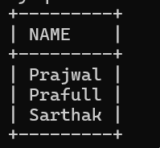
CREATE TABLE TABLE2 (
NAME VARCHAR(20)
);
SELECT * FROM TABLE2;
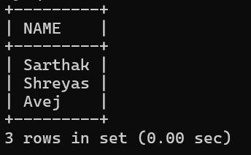
-- UNION
SELECT NAME FROM TABLE1
UNION
SELECT NAME FROM TABLE2;
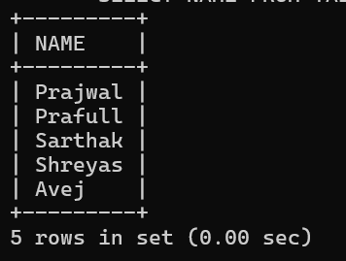
-- INTERSECT
SELECT NAME FROM TABLE1
INTERSECT
SELECT NAME FROM TABLE2;
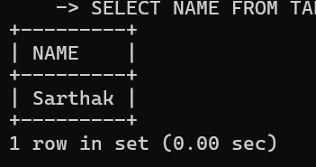
-- MINUS
SELECT NAME FROM TABLE1
WHERE NAME NOT IN (SELECT NAME FROM TABLE2);
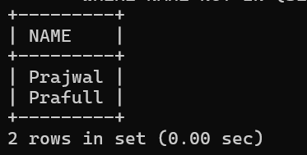
i) VIEWS
-- Create view
CREATE VIEW customer_view AS
SELECT NAME, SALARY FROM CUSTOMERS;
-- Display view
SELECT * FROM customer_view;
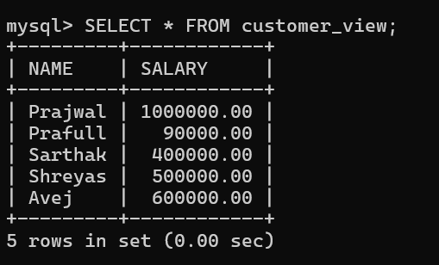
-- Drop view
DROP VIEW customer_view;
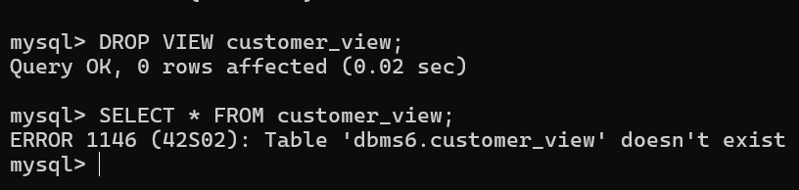
j) SORTING (ORDER BY)
-- Ascending order
SELECT * FROM CUSTOMERS
ORDER BY SALARY ASC;
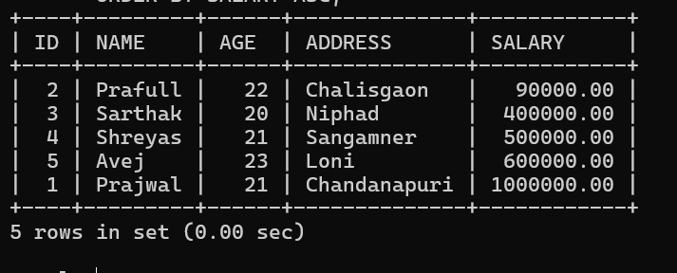
-- Descending order
SELECT * FROM CUSTOMERS
ORDER BY SALARY DESC;
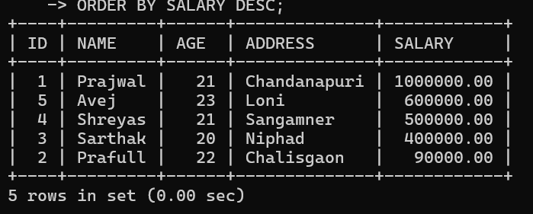

I) SQL ARITHMETIC OPERATORS
SELECT NAME, SALARY,
SALARY + 1000 AS BONUS,
SALARY - 500 AS DEDUCTION,
SALARY * 2 AS DOUBLE_SALARY,
SALARY / 2 AS HALF_SALARY,
SALARY % 2 AS REMAINDER
FROM CUSTOMERS;

